Teacher Notes for “Using Models to Understand Cellular Respiration”

In both versions of the Student Handout, students analyze two models of cellular respiration. The first model shows chemical equations that summarize the inputs and outputs of cellular respiration. The second model is a figure that shows the three major stages of cellular respiration and the role of mitochondria. After students analyze these models, they use what they have learned to develop their own more complete model of cellular respiration. In the advanced version of the Student Handout, students also analyze how the extensive, folded inner membrane of a mitochondrion contributes to ATP production. This analysis illustrates the general principle that structure is related to function.

Before students begin this activity, they should complete, “How do organisms use energy?” (https://serendipstudio.org/exchange/bioactivities/energy) or an equivalent approach to introducing ATP, cellular respiration, and hydrolysis of ATP.

Learning Goals
In accord with the Next Generation Science Standards, this activity:
- helps students to prepare for Performance Expectation HS-LS1-7, "Use a model to illustrate that cellular respiration is a chemical process whereby the bonds of food molecules and oxygen molecules are broken and the bonds in new compounds are formed resulting in a net transfer of energy."
- helps students to learn the Disciplinary Core Idea LS1.C: "Cellular respiration is a chemical process whereby the bonds of food molecules and oxygen molecules are broken”, carbon dioxide and water are formed, and the energy released is used to produce ATP from ADP and P.
- engages students in recommended Scientific Practices, including:
  - “Developing and Using Models: Develop and/or use multiple types of models to provide mechanistic accounts and/or predict phenomena, and move flexibly between model types based on merits and limitations.”
  - "Constructing Explanations: Apply scientific ideas, principles, and/or evidence to provide an explanation of phenomena…"
- can be used to illustrate the Crosscutting Concepts including:
  - "Energy and matter: Flows, cycles and conservation – Changes of energy and matter in a system can be described in terms of energy and matter flows into, out of, and within that system."
  - “Models… can be used to simulate systems and interactions – including energy, matter, and information flows – within and between systems…”
  - “Structure and Function – The functions and properties of natural and designed objects and systems can be inferred from their overall structure, the way their components are shaped and used, and the molecular substructures of its various materials.” (For the advanced version of the Student Handout)

Instructional Suggestions and Background Information
To maximize student learning, I recommend that you have your students work in pairs to complete groups of related questions. Student learning is increased when students discuss scientific concepts to develop answers to challenging questions. After students have worked together to answer each group of related questions, I recommend having a class discussion that probes student thinking and helps students to develop a sound understanding of the concepts and information covered.

Throughout these Teacher Notes, the question numbers are given for the advanced version [the simpler version] of the Student Handout. The simpler Student Handout begins with several figures and a question that review some of the anatomical and physiological context for cellular respiration.

If your students are learning online, we recommend that they use the Google Doc version of the Student Handout available at https://serendipstudio.org/exchange/bioactivities/modelCR. To answer questions 2c, 4-5, 9-11 [1, 3-4, 10], students can either print the relevant pages, draw on them and send pictures to you, or they will need to know how to modify a drawing online. To answer online, they can double-click on the relevant drawing in the Google Doc to open a drawing window. Then, they can use the editing tools to answer the questions.

You can prepare a revised version of the Student Handout, using either of the Word documents. If you use the Word documents, please check the format by viewing the PDF.

A key for each version of the Student Handout is available upon request to Ingrid Waldron (iwaldron@upenn.edu). The following paragraphs provide additional instructional suggestions and background information – some for inclusion in your class discussions and some to provide you with relevant background that may be useful for your understanding and/or for responding to student questions.

A model is a simplified representation of reality that highlights certain key aspects of a phenomenon and thus helps us to better understand and visualize the phenomenon. Many students tend to think of a model as a physical object and may not understand how a chemical equation or diagram can be a useful model. It may be helpful to introduce the idea of a conceptual model. As noted in A Framework for K-12 Science Education, “Conceptual models allow scientists… to better visualize and understand a phenomenon under investigation… Although they do not correspond exactly to the more complicated entity being modeled, they do bring certain features into focus while minimizing or obscuring others.” If your students are not familiar with conceptual models, you may want to give examples of conceptual models that students may have used, e.g. a map, a diagram of a football play, sheet music, or an outline of a chapter or a paper the student is writing.

The chemical equations on page 1 of the Student Handout summarize the inputs and outputs for cellular respiration. The upper exergonic reaction provides the energy needed for the lower endergonic reaction (https://bio.libretexts.org/Under_Construction/Purgatory/Core_(Britt's_page)/Endergonic_and_Exergonic_Reactions%23).

To answer question 1-3 [1-2, 9], students will need to remember information from the prerequisite “How do organisms use energy?” (https://serendipstudio.org/exchange/bioactivities/energy).

The figure on page 2 shows the three main stages of cellular respiration. The multiple arrows in the representations of glycolysis and the Krebs cycle suggest a little of the complexity of the reactions in cellular respiration. Glycolysis occurs in the cytosol and does not require O₂. The Krebs cycle and the electron transport chain plus ATP synthase occur inside the mitochondria. O₂ is a crucial input for the electron transport chain; none of the cellular respiration processes inside the mitochondria can proceed if there is no O₂ input for the electron transport chain. For a discussion of anaerobic production of ATP (fermentation), see “Cellular Respiration and Photosynthesis – Important Concepts, Common Misconceptions, and Learning Activities” (https://serendipstudio.org/exchange/bioactivities/cellrespiration).

The equations and figure in the Student Handout indicate that cellular respiration of one molecule of glucose generates ~29 molecules of ATP; this number is less than previously believed (and often erroneously stated in textbooks). This revised estimate is based on recently discovered inefficiencies and complexities in the function of the electron transport chain and ATP synthase enzyme. The number of ATP produced per molecule of glucose is variable because of variability in the efficiency of the electron transport chain proton pumps and the ATP synthase. These recent findings are interesting as an example of how science progresses by a series of successively more accurate approximations to the truth.

Question 5b [4b] assumes that students have already learned that the names of enzymes often end in “ase” and they know that most enzymes are proteins.

One important point to include in discussion of student answers to question 7 [6] is that mitochondria do not make energy. Energy is neither created nor destroyed in biological processes. Instead, mitochondria use the energy available from reactions that use pyruvate and oxygen to make ATP which provides energy in a form that is used for many biological processes. To reinforce student understanding that much of the ATP produced by cellular respiration is made in the mitochondria, you may want to insert the following question.

7b. During intense exercise, muscle cells produce ATP using a modified form of glycolysis, called fermentation. Fermentation does not include the Krebs cycle or the electron transport chain + ATP synthase. Which do you think produces more ATP per molecule of glucose?
cellular respiration ___ or fermentation ___
Explain your reasoning.

Question 8 [7-8] will help students understand:
- how conceptual models highlight important features of a complex process like cellular respiration
- how different conceptual models can help us to understand different features of a complex process.

Question 9 [10] can be used for formative assessment. If your students find this question too difficult, you may want to provide a word bank to help them answer this question. I recommend that, after students develop their individual answers to this question, each small group of students should develop a consensus answer on a whiteboard. A class discussion of each group’s whiteboard will provide the opportunity to reinforce student understanding of cellular respiration and clarify any misunderstandings.

The drawing for question 9 [10] shows a single enlarged mitochondrion inside the cell. In contrast, each heart muscle cell has ~5000 mitochondria and each biceps muscle cell has ~200 mitochondria (https://heartmdinstitute.com/health-and-wellness/what-are-mitochondria/).

In living cells mitochondria often change shape, grow, divide, and fuse together (http://book.bionumbers.org/how-big-are-mitochondria/). In some types of cells, mitochondria form a complex, branched system of connected mitochondria, instead of separate ovoid organelles. In these cases, the percent of cytoplasmic space taken up by mitochondria is a more meaningful estimate than the number of mitochondria per cell. This percent is estimated to be ~40% in heart muscle cells and ~20-25% in liver cells.

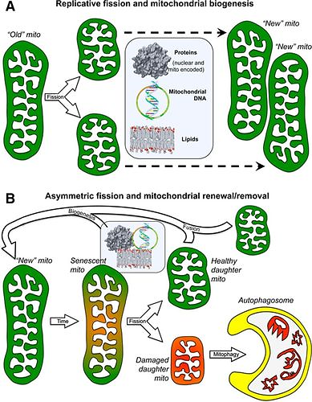
(https://www.ahajournals.org/cms/attachment/6e031764-99ce-4bf0-b842-bf66740ea8b5/167fig01.jpg)

Understanding the Structure and Function of Mitochondria
This section (in the advanced version of the Student Handout) guides students to understand the relationship between structure and function in mitochondria. Specifically, students learn how the extensive, folded inner membrane contributes to the production of ATP. If your students have learned about natural selection, you may want to explain that natural selection is the reason why structure is related to function in biology.

You may want to supplement the figures on page 4 of the Student Handout with the figure below.
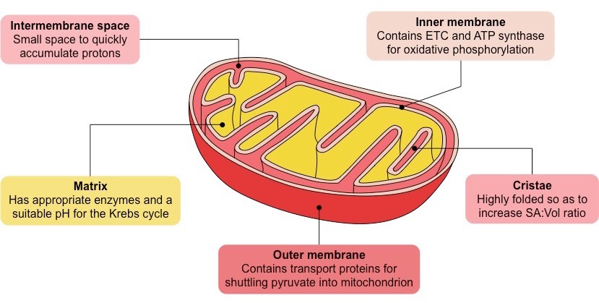
Highly folded inner membrane results in increased surface area.
(https://ib.bioninja.com.au/_Media/mitochondrion_med.jpeg)

For the lower figure on page 4 of the Student Handout, you will probably want to explain that the rectangle with colored background around the ATP synthase molecule does not mean that this space is separate or different from the rest of the intermembrane space and matrix; it just means that I lack the technical expertise to get rid of the colored background in the helpful inserted mini-figure that shows the ATP synthase molecule.

Before question 11, you may want to show your students the 1.5-minute video, “Electron Transport System and ATP Synthesis”, available at https://d.pr/v/Bnv8qZ. You may also want to use some or all of the following approaches to help your students understand mitochondrial function.
- Ask your students why the electron transport chain and ATP synthase are considered together as one stage in the process of cellular respiration. (The electron transport chain creates a H+ differential between the matrix and the intermembrane space, and this H+ differential powers ATP synthase.)
- Show the figure below, which provides an integrated overview of the multiple steps of cellular respiration.
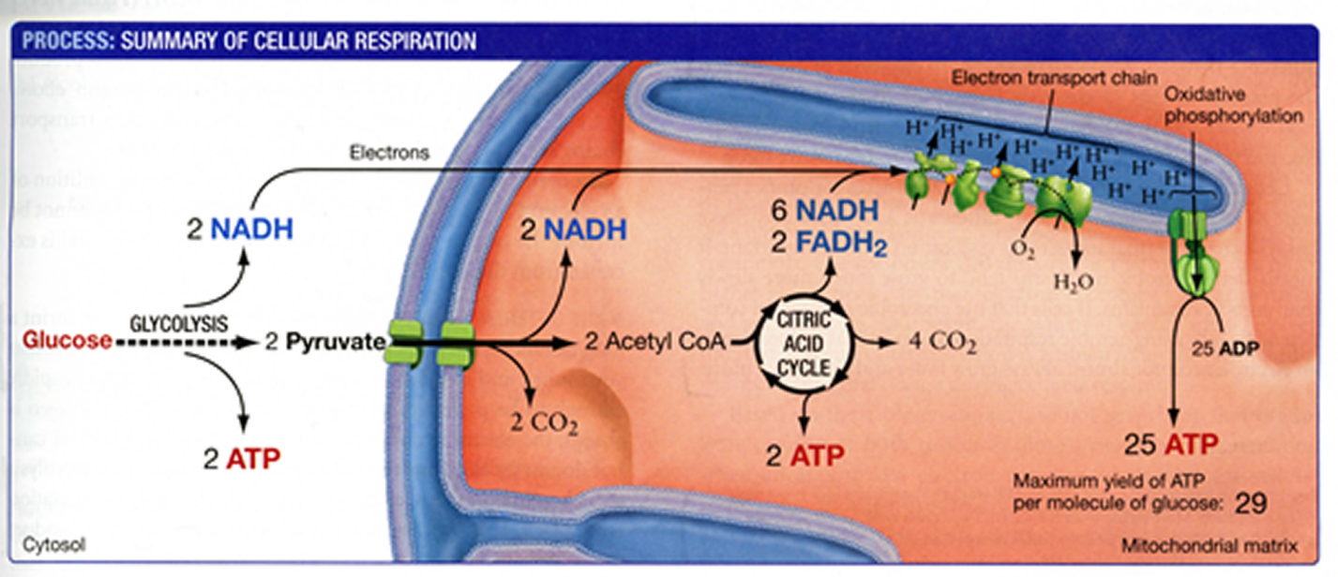(From "Biological Science" by Scott Freeman, Benjamin Cummings, 2011)
Intermembrane space

ATP synthase provides a particularly striking example of a complex molecular structure that accomplishes an important function. As shown in the figure below, the energy available from the concentration gradient of H⁺ is converted to mechanical rotational energy. The rotation of the rod inside the catalytic knob catalyzes the production of ATP.

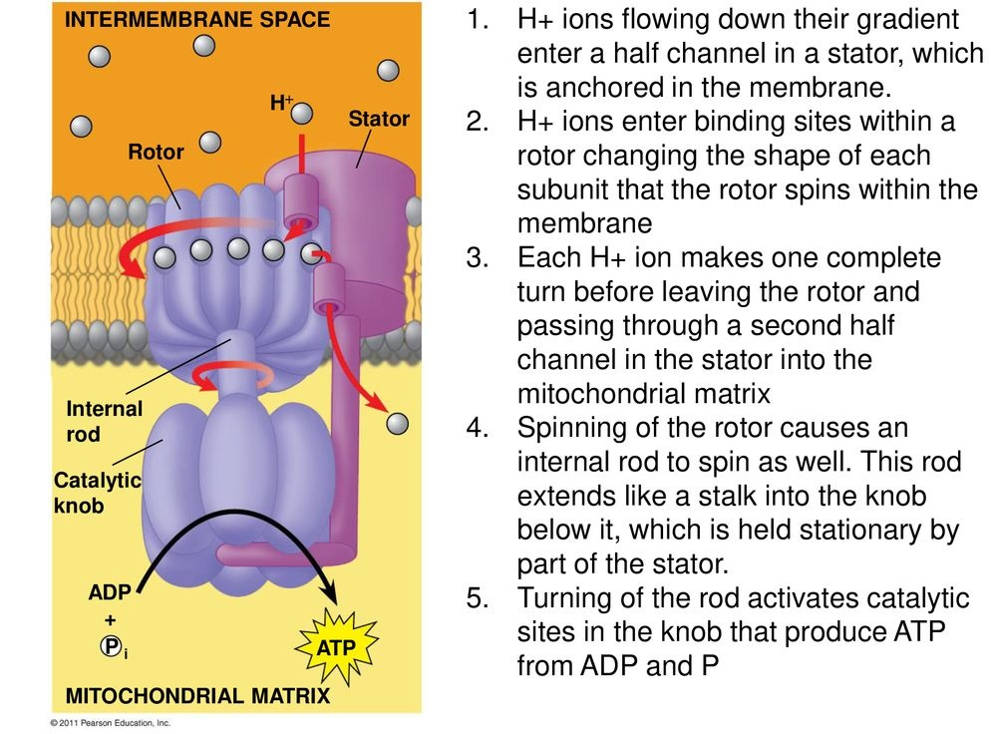
(https://slideplayer.com/slide/14082775/86/images/57/Figure+9.14+ATP+synthase%2C+a+molecular+mill..jpg)

Additional information on ATP synthase is provided in the videos available at:
- https://www.youtube.com/watch?v=3y1dO4nNaKY (~3.5 minutes).
- https://www.khanacademy.org/science/ap-biology/cellular-energetics/cellular-respiration-ap/v/atp-synthase (first 3 minutes)
- http://www.mrc-mbu.cam.ac.uk/projects/2248/molecular-animations-atp-synthase (multiple detailed videos)

This analysis of the structure and function of the inner membrane of mitochondria illustrates the general phenomenon that many proteins are embedded in the membranes of cells and their functions depend on their locations in these membranes. Additional examples of this general phenomenon are discussed in “Cell Membrane Structure and Function” (https://serendipstudio.org/sci_edu/waldron/#diffusion).

Questions 12-14 challenge students to explain the contributions to ATP synthesis of the extensive, folded inner membrane of mitochondria, based on what they learned on page 4 of the advanced version of the Student Handout. For question 12, students also need to understand that the folds of the inner membrane increase its surface area; the surface area of the inner membrane is several times larger than the surface area of the outer membrane. Question 14 returns to the general principle that, in biology, structure is related to function.

Follow-up Activities (All of these activities support the NGSS.)
How do muscles get the energy they need for athletic activity?
https://serendipstudio.org/exchange/bioactivities/energyathlete
In this analysis and discussion activity, students learn how muscle cells produce ATP by aerobic cellular respiration, anaerobic fermentation, and hydrolysis of creatine phosphate. They analyze the varying contributions of these three processes to ATP production during athletic activities of varying intensity and duration. Students learn how multiple body systems work together to supply the oxygen and glucose needed for aerobic cellular respiration. Finally, students use what they have learned to analyze how athletic performance is improved by the body changes that result from regular aerobic exercise.

Food, Energy and Body Weight
https://serendipstudio.org/exchange/bioactivities/foodenergy
This analysis and discussion activity helps students to understand the relationships between food, energy, cellular respiration, and changes in body weight. Analysis of a specific example helps students to understand how challenging it is to prevent weight gain by exercising to offset what seems to be a relatively modest lunch. In an optional research project, each student asks an additional question and prepares a report based on recommended reliable internet sources.

Using Models to Understand Photosynthesis
https://serendipstudio.org/exchange/bioactivities/modelphoto
In this analysis and discussion activity, students develop their understanding of photosynthesis by answering questions about three different models of photosynthesis. These models are a chemical equation, a flowchart that shows changes in energy and matter, and a diagram that shows the basic processes in a chloroplast. Students learn about the role of scientific models by evaluating the advantages of each of these models for understanding the process of photosynthesis.

Additional follow-up activities and general background are provided in "Cellular Respiration and Photosynthesis – Important Concepts, Common Misconceptions, and Learning Activities" (https://serendipstudio.org/exchange/bioactivities/cellrespiration).

Sources of Figures in Student Handouts
- Figures on page 1 of the simpler version, constructed by the author, using https://i.pinimg.com/736x/40/3a/93/403a9300f90176747ec1467be7b45205--human-anatomy-human-body.jpg, figure from “Biology – Science for Life with Physiology” by Belk and Borden, 2007, and https://cdn-degmb.nitrocdn.com/ttfRdoaCkYdYriFDAQYzsXWjIyYFFwdP/assets/images/optimized/rev-d26f84f/3dmusclelab.com/wp-content/uploads/2019/02/muscle-contractions.jpg
- Figure on page 2, modified from
https://sciencepolicyivh.files.wordpress.com/2015/03/3typescellrespiration.gif
- Figures on pages 3 (of both versions) and 5 (of the advanced version), constructed by the author, using cross-section of mitochondrion from https://ib.bioninja.com.au/_Media/mitopic2_med.jpeg
- Figure on top of page 4 of the advanced version, modified from
https://upload.wikimedia.org/wikipedia/commons/5/51/Figure_07_01_04.jpg
- Figure in the middle of page 4 of the advanced version, modified from
https://biologydictionary.net/wp-content/uploads/2018/08/The-Electron-Transport-Chain.jpg
and https://slideplayer.com/slide/14082775/86/images/57/Figure+9.14+ATP+synthase%2C+a+molecular+mill..jpg
General Principles

The following three principles are important for understanding energy metabolism.

- In biological processes, energy is not created or destroyed, although energy can be transformed from one type to another (e.g. chemical energy can be transformed to the kinetic energy of muscle motion).
- All types of energy transformation are inefficient and result in the production of thermal energy. For example, when hydrolysis of ATP provides the energy for muscle contraction, only about 20-25% of the chemical energy released is captured in the kinetic energy of muscle contraction. The rest of the energy from the hydrolysis of ATP is converted to thermal energy.
- The atoms in molecules can be rearranged into other molecules, but atoms (matter) is not created or destroyed.

1. Aerobic respiration occurs mainly inside the mitochondria in cells. A website claims that "The mitochondria in muscle cells make the energy needed for athletic activity." Explain what is wrong with this sentence, and give a more accurate sentence.

2. Explain why your body gets warmer when you are physically active.

3a. If you search for "cellular respiration equation" on the web, some of the most popular sites give the following chemical equation for cellular respiration of glucose.
C₆H₁₂O₆ + 6 O₂ 6 CO₂ + 6 H₂O + ATP

What is wrong with this chemical equation? (Hint: Think about where the atoms in an ATP molecule come from.)

3b. Write a corrected version of this chemical equation that gives a more accurate summary of cellular respiration.

By Dr. Ingrid Waldron, University of Pennsylvania, 2023. These Teacher Notes and the related Student Handouts are available at https://serendipstudio.org/exchange/bioactivities/modelCR
If you use a different approach to introduce ATP, cellular respiration, and hydrolysis of ATP, you may want to assign the “General Principles” page (on the last page of these Teacher Notes).
http://www.nextgenscience.org/sites/default/files/HS%20LS%20topics%20combined%206.13.13.pdf and https://www.nextgenscience.org/
To draw a shape - At the top of the page, find and click Shape. - Choose the shape you want to use. - Click and drag on the canvas to draw your shape. To insert text - At the top of the page, click Insert. - To place text inside a box or confined area, click Text Box and drag it to where you want it. - Type your text. - You can select, resize and format the word art or text box, or apply styles like bold or italics to the text. When you are done, click Save and Close.
Quotation from A Framework for K-12 Science Education: Practices, Crosscutting Concepts, and Core Ideas (available at http://www.nap.edu/catalog.php?record_id=13165).
During glycolysis, the six-carbon sugar, glucose, is broken down to two three-carbon pyruvate molecules, and two ADP + P are converted to two ATP.
The Krebs cycle is often called the citric acid cycle. Mitochondria are roughly 1 µm in diameter.
This source also explains that glucose is not the only organic molecule that cellular respiration can use to produce ATP; alternative inputs include fatty acids, glycerol, and amino acids.
"Approximate Yield of ATP from Glucose, Designed by Donald Nicholson" by Brand, 2003, Biochemistry and Molecular Biology Education 31:2-4 (available at http://www.bambed.org).
Question 9 [10] states that "The Krebs cycle produces CO₂." As shown in the figure on page 7 of these Teacher Notes, some CO₂ is also produced in the step inside the mitochondria that precedes the Krebs cycle.
¹¹ For this purpose, you will want one whiteboard per student group in your largest class. For information about how to make inexpensive whiteboards and use them in your teaching, see "The $2 interactive whiteboard" and "Resources for whiteboarding" in https://fnoschese.wordpress.com/2010/08/06/the-2-interactive-whiteboard/. To obtain whiteboards, you can go to Home Depot or Lowe's and ask them to cut a 8' x 4' whiteboard (e.g. EUCATILE Hardboard Thrifty White Tile Board) into six pieces with the dimension 32" x 24". They should have a power saw rig that allows their employees to cut the pieces very easily. They should not charge to cut them and the product cost is reasonable. Some important tips for using whiteboards: – Coat the white boards with Endust (or similar product) before using. Every once in a while, wipe them clean and reapply Endust. – Black markers are easiest to erase. To prevent stains, erase right away, especially red or green markers. Do not use markers that are old or almost empty, since the ink from these is more difficult to erase. Recommended brands are Expo markers and Pilot BeGreen markers. To clean up stains you can use Windex or Expo Whiteboard Cleaner. – Teacher and/or students can take a picture of the information on the board if they want to save it.
ATP synthase and electron transport chain I-IV (shown in the figure in the middle of page 4 of the advanced version of the Student Handout) are actually protein complexes, not individual proteins.
This is similar to how the multiple folds and villi increase the surface area of the lining of the lumen of the small intestines, which increases the area available for absorption of nutrients.

